

Practices for Secure Software Report

Table of Contents
Document Revision History 3
Client 3
Instructions 3
Developer 4
1. Algorithm Cipher 4
2. Certificate Generation 4
3. Deploy Cipher 4
4. Secure Communications 4
5. Secondary Testing 4
6. Functional Testing 4
7. Summary 4
8. Industry Standard Best Practices 4

Document Revision History

Version | Date | Author | Comments
1.0 | 12/13/2025 | Kyle Dauk | Initial secure software assessment and refactor

Client



Developer
Kyle Dauk

Algorithm Cipher

The selected cryptographic approach for Artemis Financial’s application uses the SHA-256 hashing algorithm to support data integrity verification through checksum generation. SHA-256 is a NIST-approved cryptographic hash function defined in FIPS 180-4 and produces a fixed 256-bit output.
SHA-256 was selected because it is a one-way, collision-resistant hash function that is well-suited for verifying data integrity during transmission. Unlike encryption algorithms, hashing does not use keys and cannot be reversed, which makes it ideal for checksum validation.
Older algorithms such as MD5 and SHA-1 were intentionally avoided due to known cryptographic weaknesses and collision vulnerabilities. SHA-256 remains an industry-standard algorithm and is widely used in modern secure applications and protocols, including TLS.

Certificate Generation

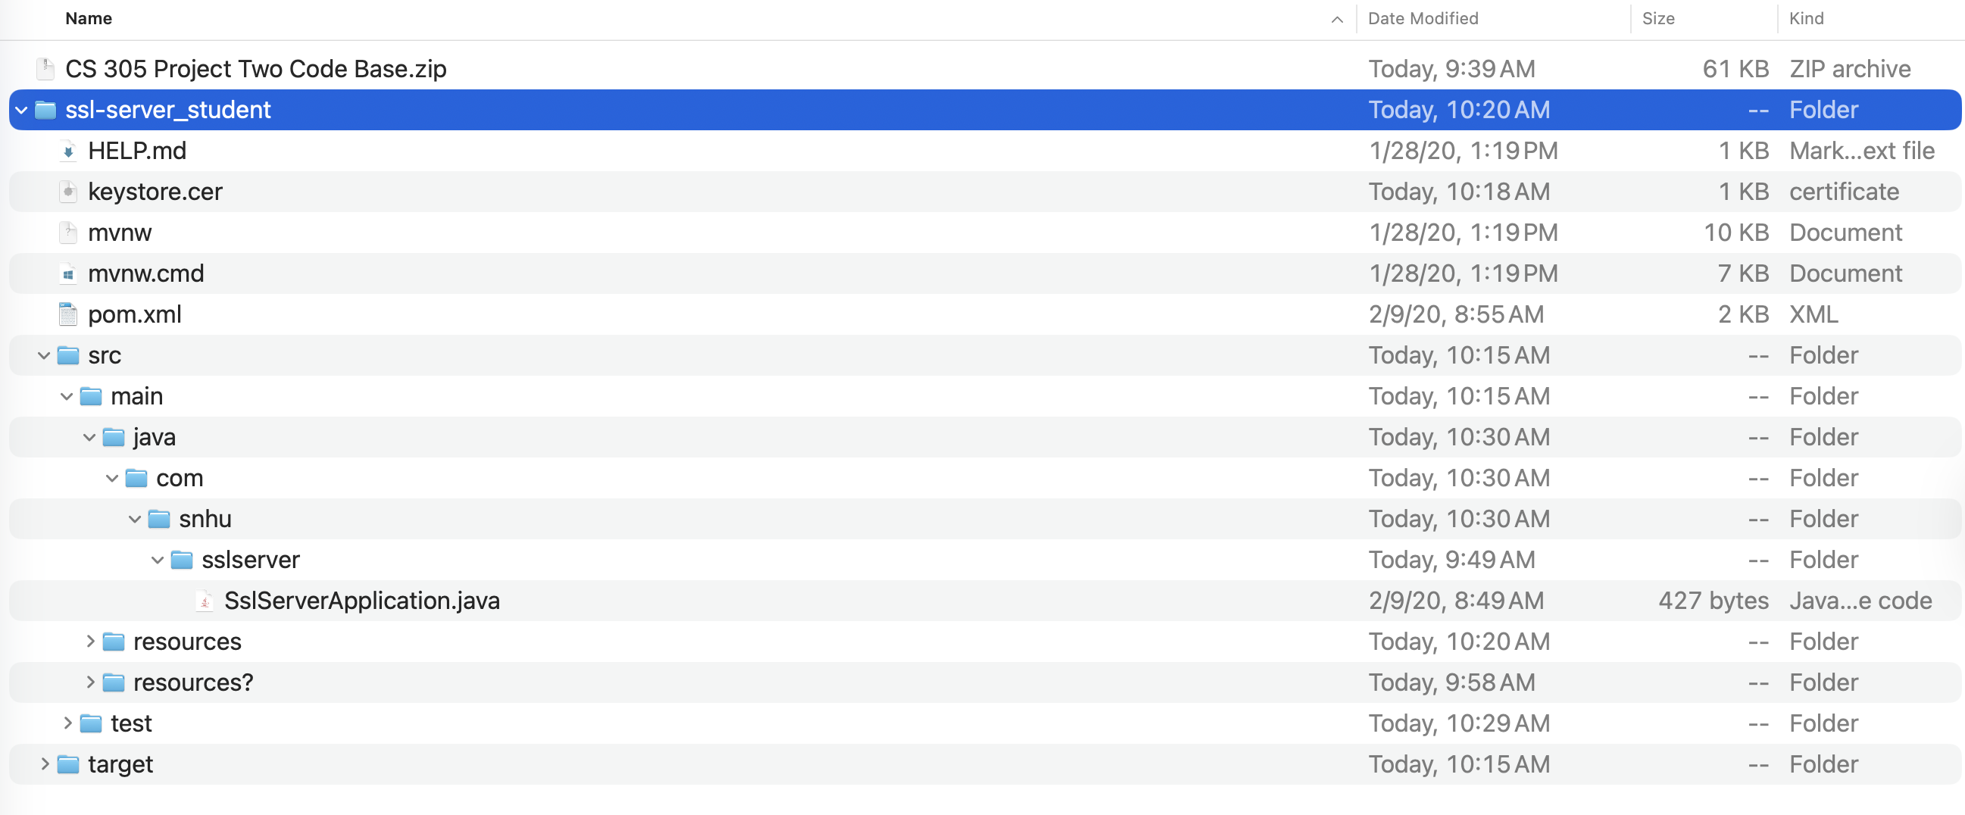

Deploy Cipher
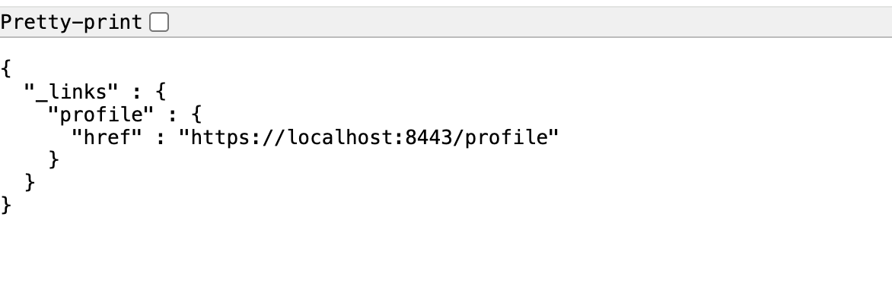

Secure Communications
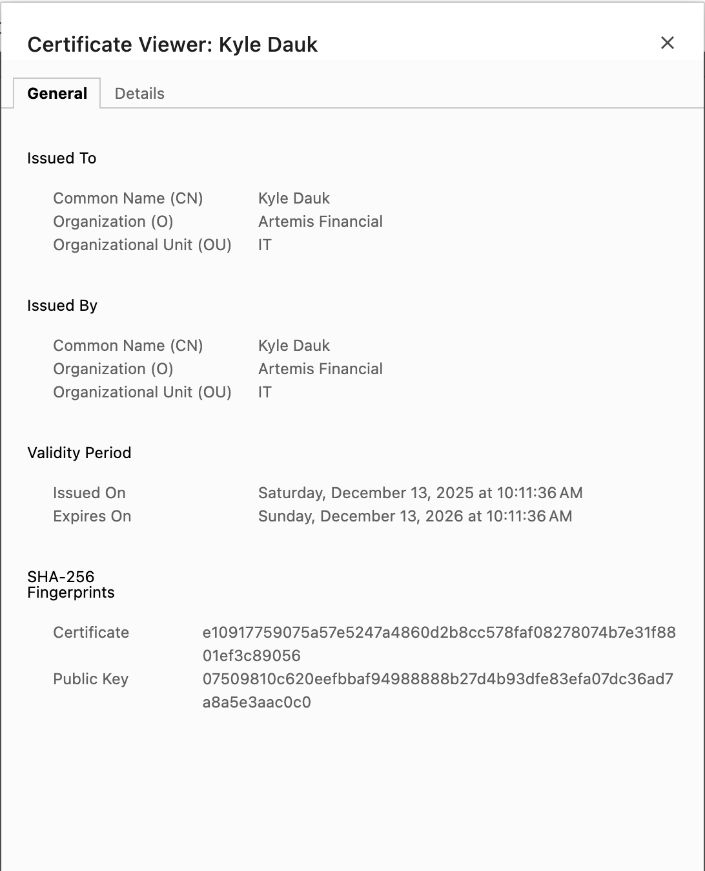

Secondary Testing

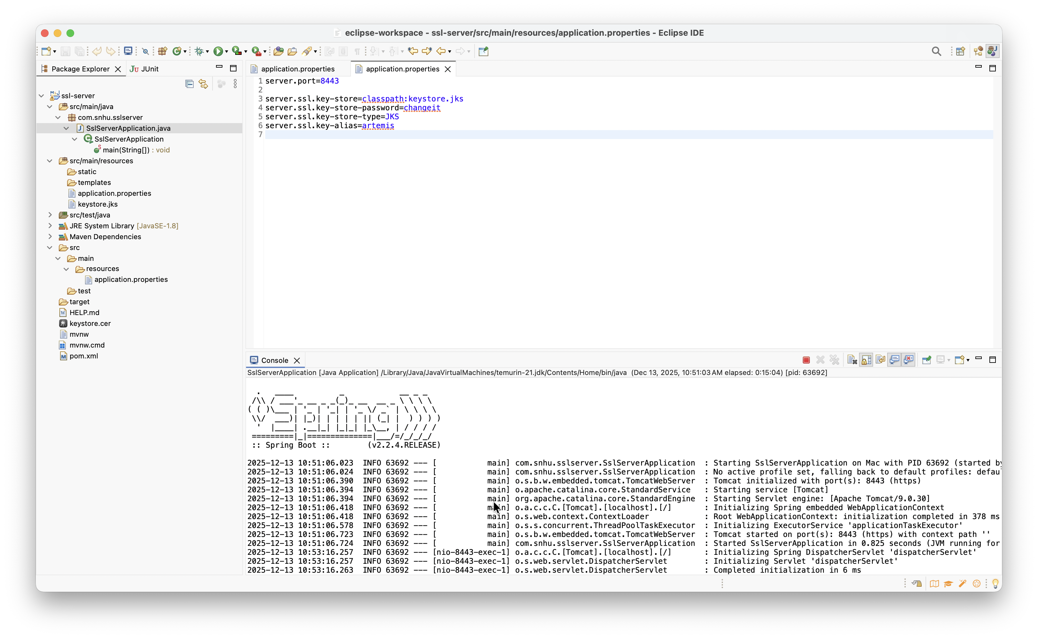Functional Testing

Summary

This project systematically followed the Vulnerability Assessment Process Flow to identify and mitigate security risks in Artemis Financial’s application.

[Insert the Vulnerability Assessment Process Flow Diagram image here. Resize to fit page width (approximately 6.5–7 inches wide) and center it.]

As depicted in the Vulnerability Assessment Process Flow diagram above, the following critical areas were addressed through targeted refactoring:

- Cryptography: Deployed SHA-256 hashing algorithm for secure checksum generation and data integrity verification during transmission.

- Client/Server: Implemented secure distributed composing by configuring HTTPS/TLS on port 8443 with a properly generated self-signed certificate.

- Code Quality: Applied secure coding practices and patterns, including robust error handling to prevent information disclosure.

OWASP Dependency-Check static testing results informed manual code reviews of relevant components (controllers, services, and APIs). No new vulnerabilities were introduced by the refactoring. The combined measures established defense-in-depth, ensuring compliance with secure software development and testing protocols while enhancing protection of sensitive financial data.

Industry Standard Best Practices

Industry standard best practices were applied throughout the refactoring process to maintain and enhance the application’s security. These practices included the use of NIST-approved cryptographic algorithms, secure TLS communication, dependency vulnerability scanning, and adherence to secure coding principles such as least privilege and defense-in-depth.
Applying these best practices helps protect sensitive financial data, reduces the likelihood of security breaches, and improves overall system reliability. For Artemis Financial, this approach supports regulatory expectations, client trust, and long-term application maintainability.

